Determination of Citrus Tree Age with Contour Detection in OpenCV and C++

Arlington Griffith and Sergio Torres

Computer Science Students

Florida Polytechnic University

Lakeland, Florida

***Abstract*—In order to treat citrus greening disease, the age of trees with the disease must be known. The authors created a program that uses the OpenCV C++ library to begin the process of approximating the age of citrus trees by determining the diameter and height of trunks based on edge detection techniques.**

***Keywords—citrus greening; huanglongbing; HLB; edge detection; citrus trees; computer vision***

# Introduction

Citrus greening disease, also known as Huanglongbing or HLB, is currently one of the largest threats to citrus crops. It is caused by bacteria, and can be spread by pests or just by contact between infected and noninfected parts of trees [2]. Since one of the treatments for citrus greening requires knowing the age of the citrus tree, the authors were tasked with creating a computer vision program that can determine the age of a citrus tree. The program takes input from a video feed and displays the length and area of the biggest contour. From this data, with further time and research, we could be able to calculate the size and thus, the age of the tree.

# Calculating Contour

The code begins by taking a live video feed from the computer’s webcam as input and displaying this in a window. The code could easily be modified to accept a picture, but this was the route we took, assuming the program would be used in the field by automated machines. Fig. 1 displays the code used to take the current frame from the video and convert this into grayscale in order to make it easier to work with. The image is then thresholded for all pixels above the value of 125. Within this modified image, we then find all of the contours. This code had its basis in [1].

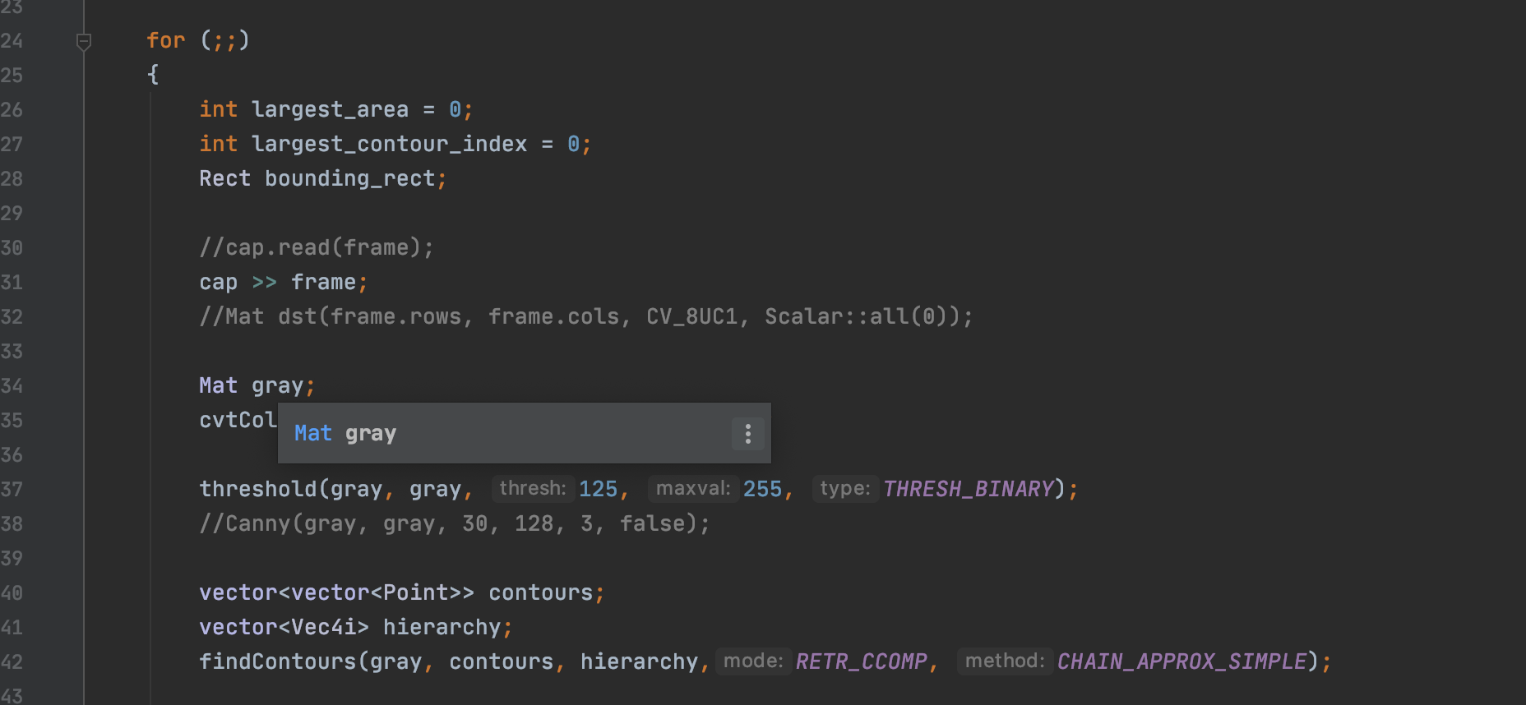

Fig. 1. Code lines 24 - 42

The code in Fig. 2 goes through all of the contours and compares them in order to find the largest, which is then put in a bounding box and displayed. The putText function should print the area and length of the biggest contour, but this functionality stopped working during the process of fixing other code, and the authors were unable to make this work again. The rest of the program, below the code in Fig. 2, draws the contours on top of the live video feed and waits for the user to press a key in order to close the windows.

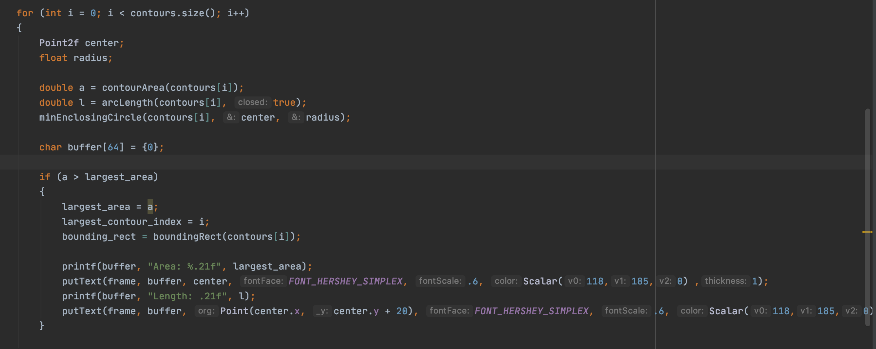

Fig. 2. Code lines 44 - 65

# Determining Tree Age

Unfortunately, the authors were unable to complete the project and the program does not determine the age of citrus trees, but with more work, the program could do so. From the largest contour, we could determine the height, mass, or trunk diameter of the tree. Alongside growth curves and equations such as those found in [3], this would allow us to approximate the age of the citrus tree. The first step toward calculating the age of the tree would be to find the appropriate distance from the tree necessary to capture its full height without other trees in the grove distracting. Knowing this distance, we could determine how tall and wide the tree is from a photo or video.

# Conclusion

Citrus greening is a serious concern for everyone, especially those living in states where citrus is a key crop, and finding ways to combat the disease is important. With the program the authors have created, a solution to the disease is one step closer. If the program is to be completed, however, further research is necessary. Ideally, specialists in the field of citrus greening disease and its treatment would be consulted in order to make the program capable of identifying the specific species of citrus and its age. If the program were to be expanded to other types of trees in addition to just varieties of citrus, the authors would likely consult experts in computer vision as well as botanists to help with classifying different species of trees based on appearance and perhaps location. Turning the program into an app has been considered, especially if it were to be expanded.

##### References

1. Arbeláez, P, et al. “Contour Detection and Hierarchical Image Segmentation.” IEEE Transactions on Pattern Analysis and Machine Intelligence, vol. 33, no. 5, May 2011, pp. 898–916, 10.1109/tpami.2010.161. Accessed 29 Apr. 2020.
2. “Citrus Greening.” USDA APHIS, www.aphis.usda.gov/aphis/resources/pests-diseases/hungry-pests/the-threat/citrus-greening/citrus-greening-hp.
3. Turrell, F. M., et al. “Growth Equations and Curves for Citrus Trees.” Hilgardia, vol. 39, no. 16, Jan. 1969, pp. 429–445, hilgardia.ucanr.edu/fileaccess.cfm?article=152705&p=DTIMDP, 10.3733/hilg.v39n16p429. Accessed 29 Apr. 2020.